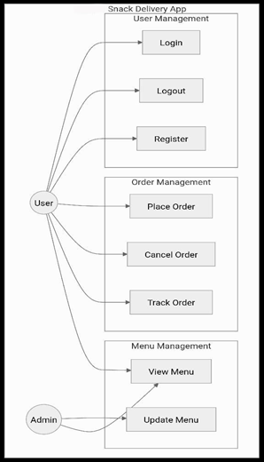**Project Design Phase-II**

**Data Flow Diagram & User Stories**

|  |  |
| --- | --- |
| Project Name | Snack Squad: A Customizable Snack Ordering and Delivery App |
| Maximum Marks | 4 Marks |

**Data Flow Diagrams:**

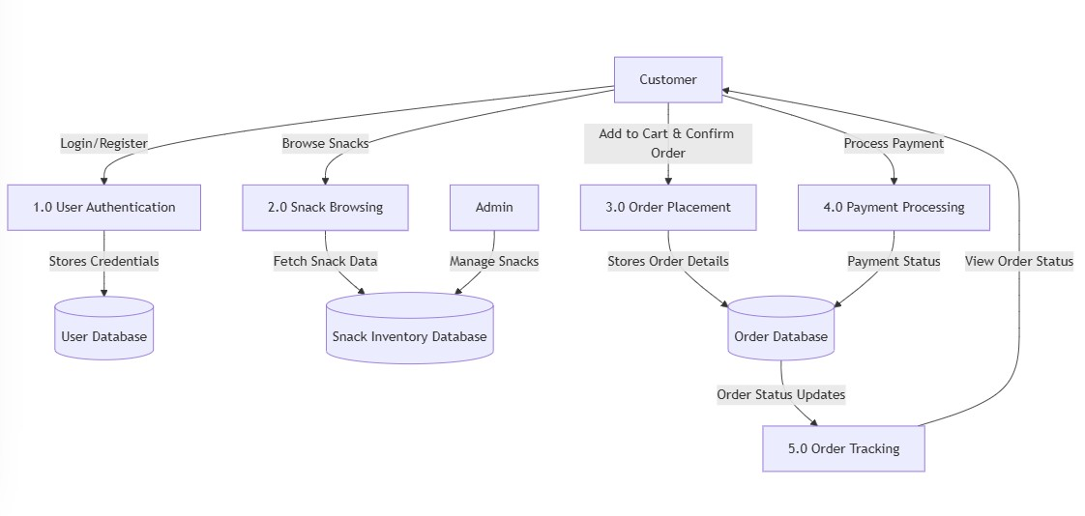

**User Stories**

Use the below template to list all the user stories for the product.

|  |  |  |  |  |  |  |
| --- | --- | --- | --- | --- | --- | --- |
| **User Type** | **Functional**  **Requirement (Epic)** | **User Story**  **Number** | **User Story / Task** | **Acceptance criteria** | **Priority** | **Release** |
| Customer  (Mobile user) | Registration | USN-1 | As a user, I can register for the application by entering my email, password, and confirming my password. | I can access my dashboard | High | Sprint-1 |
| Customer (Mobile user) | Registration | USN-2 | As a user, I will receive confirmation email once I have registered for the application | I can receive confirmation email & click confirm | High | Sprint-1 |
| Customer (Mobile user) | Snack Catalog | USN-3 | As a user, I can browse snack categories and view images/descriptions | I can register & access the dashboard with Facebook Login | Low | Sprint-1 |
| Customer (Mobile user) | Cart & Checkout | USN-4 | As a user, I can customize snack options before checkout | I can select flavor/size & view total | Medium | Sprint-2 |
| Customer (Mobile user) | Payment | USN-5 | As a user, I can pay using preferred payment method | Payment is confirmed | High | Sprint-2 |
| Customer (Mobile user) | Tracking | USN-6 | As a user, I can track my order in real-time | I receive updates till delivery | Medium | Sprint-2 |
| Customer (Web user) | Feedback | USN-7 | As a user, I can rate the snack and delivery | I can give stars/comments | Medium | Sprint2 |
| Admin | Order Management | USN-8 | As an admin, I can view all orders and assign delivery | Orders are dispatched properly | high | Sprint2 |
| Delivery Executive | Delivery View | USN-9 | As a delivery person, I can view assigned deliveries with location | I can mark order as delivered | High | Sprint2 |